

# **Govt. Graduate College Township Lahore, IT Department**

**First Deliverable**

## **SEO AI Agent**

**An AI-Powered, Web-Based SEO Automation Platform**

**Project Instructor:  
 Prof. Dr. Nabeel Sabir**

**Submitted By:**

**Kashan Haider** – Roll No. 21-3818

**Javeria Akbar** – Roll No. 21-3840

**Shahzaib Mukaram** – Roll No. 21-3807

**TABLE OF CONTENTS**

1. **Introduction**1.1 Project Overview  
   1.2 Project Objectives
2. **Feasibility Analysis**2.1 Technical Feasibility  
   2.2 Operational Feasibility  
   2.3 Economic Feasibility  
   2.4 Schedule Feasibility  
   2.5 Specification Feasibility  
   2.6 Information Feasibility  
   2.7 Motivational Feasibility  
   2.8 Legal & Ethical Feasibility
3. **Project Scope**
4. **Project Costing**4.1 Estimation Methodology (Function Point Analysis Approach)
5. **Critical Path Method (CPM) Analysis**5.1 Activity Identification  
   5.2 Sequencing & Dependencies  
   5.3 Time Estimation  
   5.4 Critical Path Identification  
   5.5 Ongoing Updates & Monitoring
6. **Gantt Chart**6.1 Phases & Milestones  
   6.2 Task Dependencies
7. **Team and Skillset Overview**
8. **Tools and Technologies**
9. **Vision Document**9.1 Vision Statement  
   9.2 Challenges Addressed  
   9.3 Proposed Solution  
   9.4 Benefits  
   9.5 Future Considerations
10. **Risk Assessment**10.1 Technical Risks  
    10.2 Operational Risks  
    10.3 Economic Risks  
    10.4 Legal & Ethical Risks
11. **Requirements Engineering**11.1 System Specifications

11.1.1 Overview

11.1.2 Key Functional Specifications

11.2 Identifying External Entities  
11.3 Context-Level Data Flow Diagram  
11.4 Functional Requirements ("Shall" Statements)

11.4.1 SEO Audit Module

11.4.2 Data Integration Module

11.4.3 AI Recommendation Module

11.4.4 Dashboard & Reporting Module

11.4.5 User Management & Security

11.5 Allocating Requirements  
11.6 Prioritizing Requirements  
11.7 High-Level Use Case Diagram

1. **Design Models**12.1 System Architecture  
   12.2 Class Diagram  
   12.3 Sequence Diagram  
   12.4 Activity Diagram

**1. INTRODUCTION**

### **1.1 Project Overview**

**SEO AI Agent** is an AI-powered, web-based platform designed to automate comprehensive SEO tasks for businesses. This innovative system will:

* **Automate SEO Audits:** Covering technical, on-page, and off-page factors.
* **Perform Keyword Research & Competitor Analysis:** Using advanced AI algorithms.
* **Provide On-Page Optimization Recommendations:** Tailored to improve search rankings.
* **Deliver Content Strategy & Link-Building Analysis:** To boost organic traffic.
* **Integrate with Third-Party APIs:** Such as Google Analytics, to fetch real-time data.
* **Present Actionable Insights:** Via an intuitive, responsive dashboard.

### **1.2 Project Objectives**

The primary objectives of the SEO AI Agent project include:

* **Streamline SEO Processes:** By automating audits, research, and analysis.
* **Enhance Data-Driven Decisions:** Empowering businesses with actionable insights.
* **Increase Operational Efficiency:** Reducing the manual workload of SEO professionals.
* **Improve Search Rankings:** Through precise on-page and off-page optimizations.
* **Facilitate Seamless Integrations:** With third-party platforms for real-time data and reporting.
* **Deliver a Scalable and Robust Platform:** Using modern web technologies and AI frameworks.

**2. FEASIBILITY ANALYSIS**

This section examines the viability of the SEO AI Agent platform across several dimensions, ensuring a robust project with well-planned risk mitigation.

### **2.1 Technical Feasibility**

* **Modern Web Frameworks:** Next.js and React.js provide a responsive, SEO-optimized frontend with server-side rendering, enhancing performance and maintainability.
* **Robust Backend:** Flask offers a lightweight, flexible framework for building RESTful APIs and integrating diverse data sources.
* **Database Reliability:** PostgreSQL is selected for its stability, scalability, and advanced security features, handling complex queries and large data volumes.
* **AI Integration:** Tools like LangChain and Ollama enable real-time, context-aware SEO recommendations through advanced AI workflows.
* **API Integrations:** Seamless connections with third-party services (e.g., Google Analytics) ensure real-time data processing and up-to-date insights.

### **2.2 Operational Feasibility**

* **User-Centric Design:** An intuitive interface simplifies complex SEO data, boosting user adoption.
* **Automation:** Automating routine tasks (e.g., audits, keyword tracking) minimizes manual effort and errors.
* **Scalability:** The system is architected to manage growing data and user traffic without performance loss.
* **Support & Maintenance:** Proactive updates, continuous monitoring, and dedicated support ensure reliable operations.

### **2.3 Economic Feasibility**

* **Cost Savings:** Automation reduces labor-intensive tasks, lowering operational costs.
* **ROI:** Faster audits and improved SEO performance drive higher revenue potential.
* **Budget Considerations:** A well-structured budget, including contingency funds, ensures economic viability.

### **2.4 Schedule Feasibility**

* **Project Duration:** The project is scheduled for six months (October 20, 2024 – June 20, 2025).
* **Milestones & Phases:** Clearly defined phases and milestones support effective progress tracking.
* **Resource Allocation:** A skilled three-member team works in parallel across tasks, ensuring efficient execution.

### **2.5 Specification Feasibility**

* **Well-Defined Functionalities:** Detailed specifications guide development and reduce scope creep.
* **Modular Design:** A modular architecture supports easy enhancements and future scalability.
* **Interoperability:** Seamless integration with existing systems and standards ensures consistent performance.

### **2.6 Information Feasibility**

* **Data Availability:** Real-time data from various sources provides comprehensive performance insights.
* **Structured Data Management:** PostgreSQL ensures organized data storage, fast retrieval, and consistency.
* **Data Security:** Advanced encryption, regular audits, and compliance checks protect sensitive information.

### **2.7 Motivational Feasibility**

* **Market Demand:** Growing reliance on automated SEO solutions validates the project’s strategic importance.
* **User Empowerment:** Real-time analytics empower users to make informed, data-driven decisions.
* **Innovation:** Cutting-edge AI integration distinguishes the platform in a competitive market.

### **2.8 Legal & Ethical Feasibility**

* **Data Privacy:** Adhering to regulations like GDPR ensures robust protection of user data.
* **Intellectual Property:** All components are either developed in-house or properly licensed, reducing legal risks.
* **Transparency:** Clear documentation and open operations build trust among users.
* **Ethical Considerations:** Commitment to fairness and unbiased analysis underpins responsible AI use in SEO.

## **3. PROJECT SCOPE**

The scope of the SEO AI Agent project encompasses the complete automation of SEO tasks, aimed at transforming how businesses manage and optimize their online presence. This platform is designed to cover every aspect of SEO, from automated audits to advanced analytics, ensuring a comprehensive solution that adapts to evolving digital landscapes. Below is an in-depth exploration of the key components included in the project scope:

**Automated SEO Audits:**The platform will perform extensive SEO audits that cover technical, on-page, and off-page factors.

* **Technical Audits:** These include checks for website speed, mobile responsiveness, indexability, crawl errors, and structured data compliance. The system will continuously monitor server responses, analyze site architecture, and detect any underlying technical issues that might affect search rankings.
* **On-Page Audits:** The tool will evaluate content quality, meta tags, header usage, keyword distribution, and internal linking structures. It will analyze page content against best practices and recommend improvements for optimization.
* **Off-Page Audits:** Automated checks for backlinks, domain authority, social signals, and overall online reputation will be conducted. The platform will integrate data from external sources to assess the website’s standing in the broader digital ecosystem.

**Keyword & Competitor Analysis:**The project will provide in-depth insights to formulate effective SEO strategies.

* **Keyword Research:** Advanced algorithms will identify high-potential keywords, analyze search volumes, competition levels, and relevance to user intent.
* **Competitor Benchmarking:** The system will track competitors' SEO performance, comparing metrics such as backlink profiles, keyword rankings, and content strategies. This analysis will enable businesses to understand their competitive landscape and identify opportunities for improvement.
* **Strategic Recommendations:** Based on the collected data, the platform will suggest tailored strategies that include long-tail keywords, niche targeting, and content gaps that can be exploited for competitive advantage.

**Optimization Recommendations:**The platform is engineered to offer real-time, actionable advice to enhance website performance.

* **Real-Time Feedback:** Continuous monitoring of website performance metrics allows the system to provide immediate recommendations when issues arise.
* **Actionable Insights:** Whether it's optimizing meta descriptions, restructuring content, or enhancing image alt texts, the system delivers clear, prioritized suggestions for improvements.
* **Adaptive Algorithms:** As the SEO landscape evolves, the platform’s AI-driven models will adjust their recommendations to reflect the latest search engine algorithms and industry best practices.

**Dashboard & Reporting:**An intuitive dashboard is at the heart of the SEO AI Agent platform, presenting real-time analytics and performance metrics in a user-friendly format.

* **Visual Analytics:** Interactive graphs, charts, and heatmaps will visualize key SEO metrics, allowing users to easily understand trends and performance indicators.
* **Customizable Reports:** Users can generate detailed reports tailored to their specific needs, with options to export data in various formats for further analysis.
* **Performance Tracking:** The dashboard will display critical KPIs such as organic traffic, bounce rates, conversion rates, and keyword rankings, enabling continuous performance monitoring and iterative strategy refinement.

**Third-Party Integrations:**Seamless connectivity with external APIs, such as Google Analytics, is a fundamental aspect of the project scope.

* **Data Synchronization:** Real-time data is pulled from various sources, ensuring that the platform's insights are always up-to-date and reflective of current performance.
* **API Connectivity:** The system is designed to integrate effortlessly with multiple external tools and services, facilitating comprehensive data analysis and broader ecosystem interoperability.
* **Enhanced Functionality:** These integrations allow the platform to extend its capabilities, combining in-house analytics with industry-standard metrics for a more complete overview.

**Customization & Scalability:**A modular design approach ensures that the SEO AI Agent platform can be tailored to meet the unique needs of different businesses.

* **Modular Architecture:** Each component of the platform is developed as an independent module, allowing for easy customization and the addition or removal of features based on user requirements.
* **Scalable Infrastructure:** Designed to handle varying volumes of traffic and data, the system can scale horizontally as the business grows. This ensures that performance remains optimal regardless of the number of users or the size of the data sets.
* **Configurable Settings:** Users will have the flexibility to configure various aspects of the platform, from setting custom SEO benchmarks to defining unique reporting formats and alert thresholds.

**User Management & Security:**Ensuring robust user management and data security is paramount.

* **Role-Based Access Control:** The platform will implement granular access controls, ensuring that users only have access to the features and data relevant to their roles. This helps maintain data integrity and privacy.
* **Secure Data Handling:** Advanced encryption protocols and secure data storage practices are embedded throughout the system. Regular security audits and compliance checks will be conducted to safeguard against unauthorized access and data breaches.
* **Audit Trails and Monitoring:** Detailed logs and audit trails will track user activities, ensuring transparency and accountability. This functionality is critical for maintaining trust and ensuring compliance with data protection regulations.

**4. PROJECT COSTING**

Project costing is essential to keep the project within budget while delivering all required functionalities. For SEO AI Agent, we employ Function Point Analysis (FPA) to estimate the project’s size, complexity, and overall cost.

### **4.1 Estimation Methodology**

* **Function Point Analysis (FPA):**FPA quantifies the software’s functionality by evaluating:

1. **User Inputs:** Data entry points (e.g., audit forms, keyword fields).
2. **User Outputs:** Outputs such as reports, dashboards, and optimization recommendations.
3. **User Inquiries:** Interactive queries for real-time SEO insights.
4. **Files & External Interfaces:** Interactions with PostgreSQL, third-party APIs (e.g., Google Analytics), and AI services (LangChain, Ollama).

* **Calculation Process:**

1. **Identify & Categorize:** List all functional components.
2. **Assign Weights:** Based on complexity (simple, average, or complex).
3. **Sum Values:** Calculate the raw Function Point (FP) count.
4. **Adjust with VAF:**Adjusted FP = Raw FP × (0.65 + 0.01 × ∑ GSC Ratings)  
   (GSCs assess factors like data communications, performance, etc.)

* **Cost Estimation:**Multiply the Adjusted FP by the cost per FP (considering labor rate and productivity). For example, if the cost per FP is $200 and Adjusted FP is 500, then Total Project Cost = 500 × $200 = $100,000.
* **Sensitivity & Risk Adjustments:**Perform sensitivity analysis to understand cost impact from variations in key parameters and include a contingency buffer for unforeseen challenges.
* **Effort & Schedule Impact:**

1. **Resource Allocation:**Estimate total effort (in person-months) as:  
   Total Effort (PM) = Adjusted FP / Productivity Parameter.
2. **Scheduling Adjustments:**Plan parallel work streams (e.g., simultaneous frontend and backend development) and break down FP estimates by milestones to ensure delivery within the six-month timeline.
3. **Contingency Planning:**Add a contingency factor (typically 10–20%) to account for potential delays.

# **5. CPM – CRITICAL PATH METHOD**

The Critical Path Method (CPM) is an essential project management tool that allows us to identify the sequence of critical tasks determining the overall project duration. CPM provides a structured approach to project planning by breaking down the project into a series of activities, identifying dependencies, estimating durations, and continuously updating progress to ensure that the project stays on schedule. Maintaining a clear and consistent layout with uniform font sizes and design, the following detailed explanation expands upon each key step:

### **Activity Identification**

* **Comprehensive Task Listing:**Every activity—from initial requirements gathering through final deployment—must be identified and documented. This involves creating a thorough Work Breakdown Structure (WBS) that includes all individual tasks, subtasks, and deliverables.
* **Detailing Each Task:**Each activity is described in detail, outlining specific actions, responsible parties, and expected outcomes. This clarity helps ensure that no critical steps are missed.
* **Documentation and Visual Mapping:**Tasks are organized in a logical sequence and mapped out visually. This mapping forms the basis of the CPM network diagram, making it easier to see how tasks interconnect.

### **Sequencing & Dependencies**

* **Establishing Task Order:**Once all tasks have been identified, the next step is to determine the correct sequence. This means understanding which tasks can be executed in parallel and which must be completed sequentially.
* **Dependency Analysis:**Identify the dependencies between tasks. For example, frontend development cannot begin until the UI/UX design is finalized, and API integration must wait for backend functionalities to be established.
* **Critical Dependency Documentation:**Document all dependencies explicitly to ensure that potential bottlenecks or overlaps are identified early. This step is crucial for proper scheduling and risk mitigation.

### **Time Estimation**

* **Assigning Durations:**Each task is assigned an estimated duration based on historical data, expert judgment, and team estimates. This provides a realistic view of how long each activity should take.
* **Utilizing Historical Data and Benchmarks:**Past projects and industry benchmarks are used as a reference to fine-tune these estimates, ensuring that the projected times are both ambitious and achievable.
* **Incorporating Buffers:**Where uncertainties exist, buffers are built into the schedule to account for potential delays. This ensures that the project remains resilient to unforeseen challenges.

### **Critical Path Identification**

* **Determining the Longest Path:**The critical path is defined as the longest sequence of dependent tasks that must be completed on time for the project to be finished as scheduled. Any delay in these tasks will directly impact the overall project timeline.
* **Calculating Key Parameters:**For each task on the critical path, key metrics such as the earliest start (ES), earliest finish (EF), latest start (LS), and latest finish (LF) are calculated. The difference between these values gives the total slack or float for non-critical tasks.
* **Focus on Zero Slack:**Tasks with zero slack are considered critical. They represent the tasks where any delay would have a cascading effect on subsequent activities, thereby extending the project duration.
* **Using Software Tools:**Project management software can automatically calculate and update the critical path, providing visual dashboards and reports to facilitate real-time monitoring.

### **Ongoing Updates and Monitoring**

* **Regular Progress Reviews:**As the project progresses, the CPM diagram is continuously updated to reflect actual task completion times versus planned durations. This helps in identifying deviations early.
* **Dynamic Adjustments:**If any task on the critical path experiences a delay, adjustments are made immediately—either by reallocating resources, rescheduling tasks, or even revising estimates—to mitigate the impact on the overall timeline.
* **Integration with Risk Management:**The CPM is closely linked with risk management practices. By monitoring the critical path, project managers can quickly identify risks that may cause delays and implement contingency plans.
* **Communication and Reporting:**Regular status meetings and progress reports ensure that all stakeholders are informed of any changes in the critical path, keeping everyone aligned and focused on the most time-sensitive tasks.
* **Visual Updates:**The CPM diagram, maintained with consistent fonts and design aesthetics, serves as a visual communication tool. It provides clarity and transparency, ensuring that all team members understand their roles and deadlines.

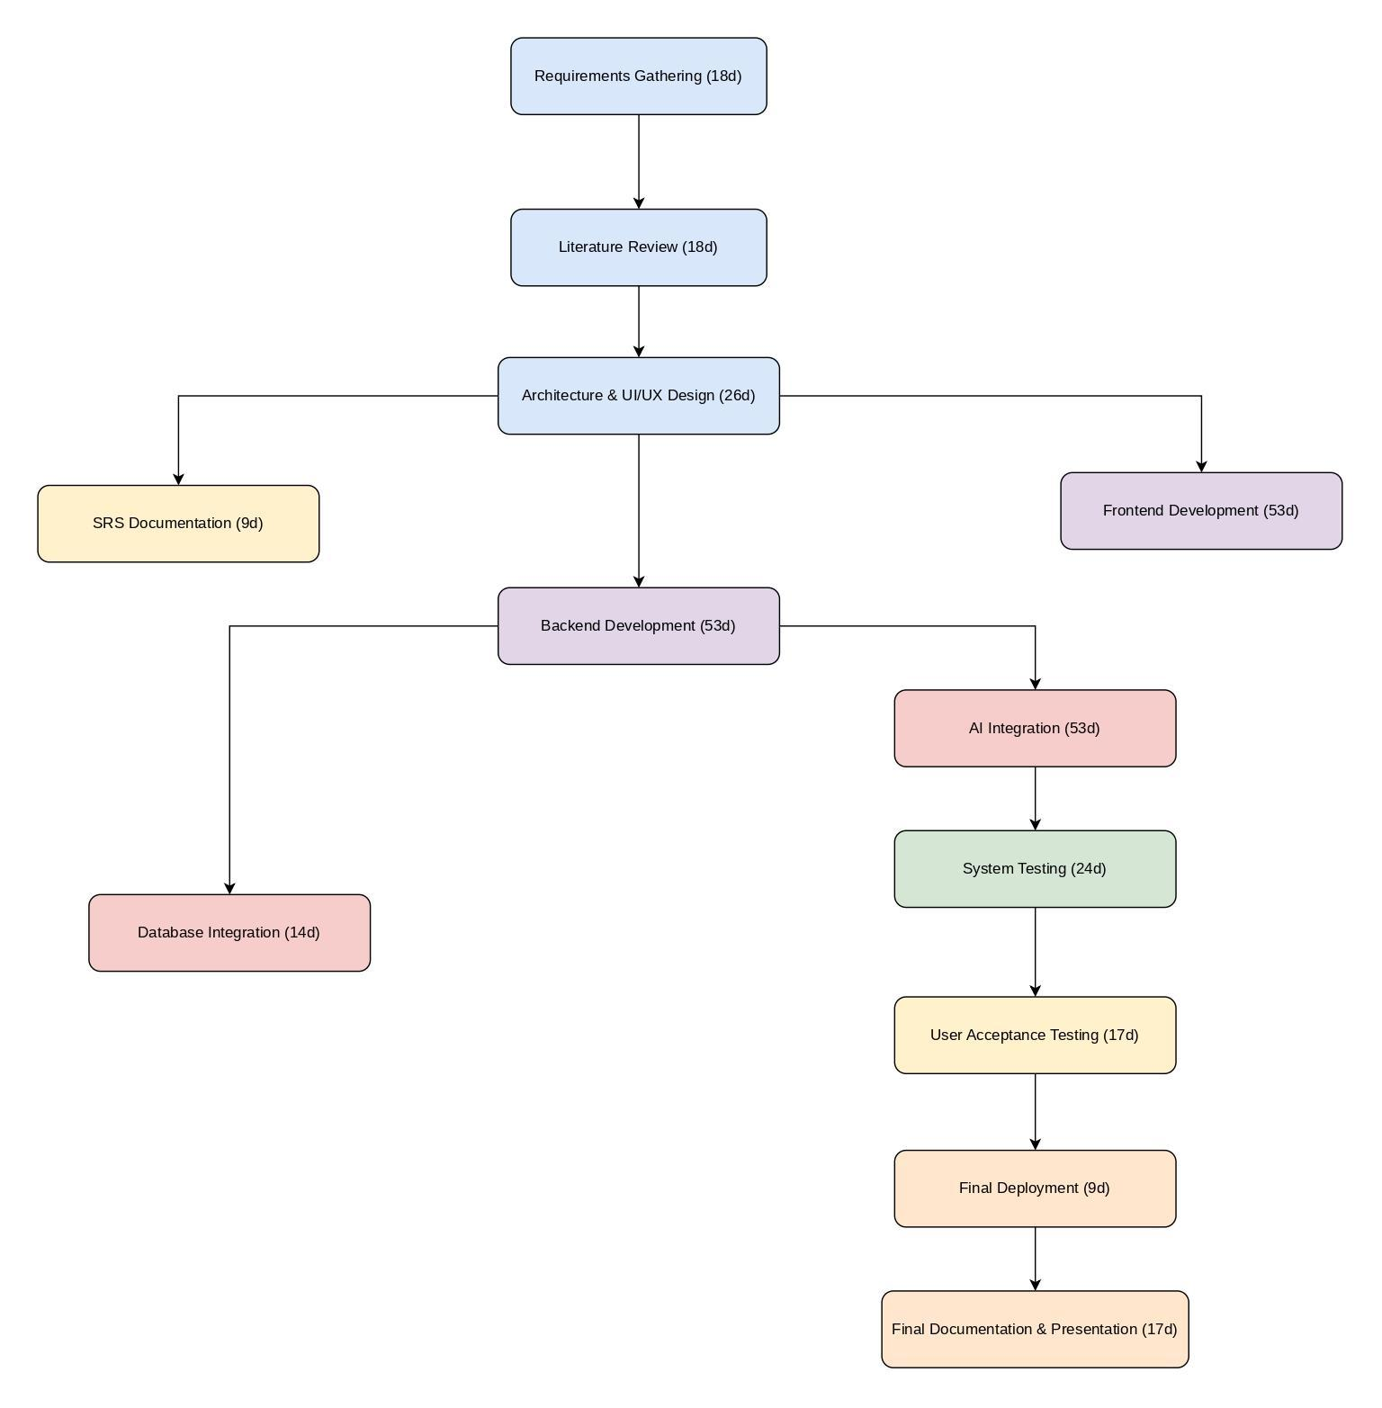

## **6. GANTT CHART**

A comprehensive Gantt chart to visualize the entire project timeline, providing a clear and detailed representation of each phase of the SEO AI Agent project. This chart serves as an essential project management tool that facilitates planning, scheduling, and tracking progress throughout the development lifecycle.

### **Phases**

The project is divided into several key phases, each with defined durations to ensure a structured workflow. The phases are as follows:

* **Requirements Gathering (18 days):**In this phase, all stakeholders collaborate to collect, analyze, and document the functional and non-functional requirements of the system. Activities include stakeholder interviews, workshops, and market analysis to ensure all user needs are clearly identified.
* **Literature Review (18 days):**This phase involves reviewing existing research, industry standards, and best practices related to SEO automation and AI integration. The objective is to ground the project in proven methodologies and to identify innovative approaches for the platform.
* **Architecture & UI/UX Design (26 days):**A critical phase where the system architecture is designed, and the user interface is conceptualized. Detailed wireframes, prototypes, and design mockups are developed, ensuring that the platform is both technically robust and user-friendly.
* **SRS Documentation (9 days):**In this phase, a comprehensive Software Requirements Specification (SRS) document is produced. This document serves as the blueprint for the development process, outlining all system functionalities, design considerations, and performance criteria.
* **Frontend Development (53 days):**The frontend team works on building a responsive, SEO-optimized user interface using modern frameworks such as Next.js and React.js. This phase focuses on creating interactive components, implementing design specifications, and ensuring cross-browser compatibility.
* **Backend Development (53 days):**Parallel to the frontend work, the backend team develops the server-side logic using Flask. This phase includes creating RESTful API endpoints, establishing robust business logic, and integrating essential services and middleware.
* **Database Integration (14 days):**In this phase, PostgreSQL is set up and integrated into the system. Activities include designing the database schema, ensuring data integrity, optimizing queries, and establishing secure data connections between the backend and the database.
* **AI Integration (53 days):**The integration of advanced AI functionalities using LangChain and Ollama is performed during this phase. This involves developing and integrating AI workflows, implementing Retrieval Augmented Generation (RAG), and testing the accuracy of automated SEO recommendations.
* **System Testing (24 days):**Comprehensive testing is conducted to validate that all components of the system work as expected. This includes unit testing, integration testing, and performance testing to ensure that the platform meets all quality standards.
* **User Acceptance Testing (17 days):**Real-world testing is performed with a group of target users to gather feedback and verify that the system meets business needs. This phase focuses on usability, functionality, and ensuring that the platform is intuitive for end-users.
* **Final Deployment (9 days):**The platform is prepared for launch with final deployment procedures, including setting up production environments, conducting final security audits, and ensuring seamless integration with third-party services.
* **Final Documentation & Presentation (17 days):**This concluding phase involves compiling comprehensive documentation, user manuals, and technical guides. A formal presentation is prepared to demonstrate the project’s achievements and to provide stakeholders with a detailed overview of the final deliverable.

### **Milestones**

Key milestones are embedded within the Gantt chart to mark significant achievements and ensure that the project remains on track. These milestones include:

* **Completion of Design:**Finalization of the architecture and UI/UX design, ensuring that all design elements are approved before development commences.
* **Integration of Core Functionalities:**Successful integration of major system components such as frontend interfaces, backend services, and AI modules.
* **Final Testing Before Deployment:**Completion of all testing phases, ensuring that the system is fully validated, stable, and ready for deployment.

These milestones act as critical checkpoints that help in assessing the progress of the project and in making timely adjustments if necessary.

### **Task Dependencies**

The Gantt chart also outlines task dependencies, which are vital for ensuring that tasks are executed in the correct order:

* **Sequential Tasks:**Tasks that must be completed in a specific order are clearly marked. For instance, frontend development is scheduled only after the UI/UX design phase is complete, and backend development depends on the finalized system architecture.
* **Parallel Work Streams:**Certain tasks can be performed concurrently to optimize time. For example, while the frontend team focuses on user interface development, the backend team can simultaneously work on API development, provided that the core requirements are already defined.
* **Buffer and Contingency Planning:**The chart includes built-in buffers to account for potential delays, ensuring that any dependency issues do not cascade and impact the overall project timeline.

By carefully mapping out these task dependencies, the project plan ensures that sequential tasks are properly scheduled and that any delays in one phase are mitigated by adjustments in others. This systematic approach minimizes the risk of bottlenecks and ensures a smooth progression from project inception to final delivery.

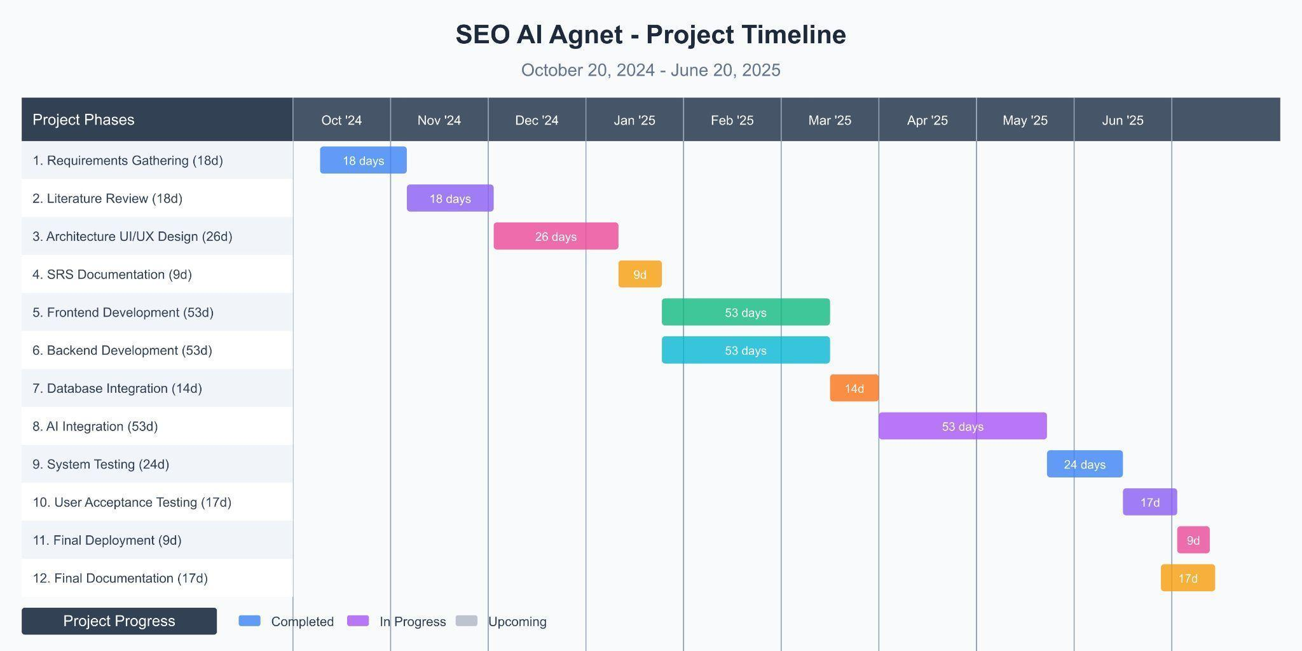

## **7. TEAM AND SKILLSET OVERVIEW**

The success of the SEO AI Agent project relies on the diverse skills and expertise of the team:

### **Kashan Haider – Roll No. 060030**

**Role:** Project Lead and Backend Developer  
**Skills:**

* Expertise in Python (Flask) and RESTful API development
* Database design and PostgreSQL management
* Experience in integrating third-party APIs
* Strong leadership and project management abilities

### **Javeria Akbar – Roll No. 060056**

**Role:** Frontend Developer and UI/UX Designer  
**Skills:**

* Proficient in Next.js, React.js, and Tailwind CSS
* Expertise in responsive web design and modern UI/UX principles
* Skilled in prototyping and wireframing
* Excellent communication for cross-team collaboration

### **Shahzaib Mukaram – Roll No. 060060**

**Role:** AI Integration & Documentation Specialist  
**Skills:**

* Experience with AI frameworks such as LangChain and Ollama
* Capable of implementing Retrieval Augmented Generation (RAG) workflows
* Strong technical documentation and testing abilities
* Proficient in integrating AI modules with web applications

**8. TOOLS AND TECHNOLOGIES**

The development of SEO AI Agent utilizes a modern technology stack and tools:

|  |  |  |  |
| --- | --- | --- | --- |
| **Category** | **Tool/Technology** | **Description** | **Key Features & Benefits** |
| **Frontend Development** | **Next.js & React.js** | These modern JavaScript frameworks provide a robust foundation for building a high-performance, SEO-friendly user interface. Next.js enables server-side rendering and static site generation, while React.js offers a component-based architecture for creating dynamic and reusable UI elements. | - **Fast Performance:** Optimized rendering and load times.  - **SEO Optimization:** Enhanced search engine visibility through server-side rendering.  - **Modular Architecture:** Facilitates code reuse and easier maintenance. |
| **Frontend Development** | **Tailwind CSS** | A utility-first CSS framework that allows for rapid styling and responsive design. Tailwind CSS minimizes the need for custom CSS by providing pre-defined classes, which speeds up the development process while ensuring consistency and flexibility across various devices and screen sizes. | - **Rapid Prototyping:** Quickly build and iterate on designs.  - **Consistency:** Uniform styling across the application.  - **Responsive Design:** Easily adapts to different screen sizes. |
| **Backend Development** | **Flask (Python)** | Flask is a lightweight Python web framework that is ideal for developing RESTful API endpoints and handling business logic. Its minimalistic approach allows developers to integrate only the necessary components, making it both efficient and scalable for complex back-end operations. | - **Lightweight & Flexible:** Minimal overhead with extensive customization.  - **Rapid Development:** Quick to prototype and deploy.  - **Extensible:** A wide range of extensions support various functionalities. |
| **Database** | **PostgreSQL** | A robust relational database management system renowned for its reliability, scalability, and advanced security features. PostgreSQL is designed to handle complex data operations, support ACID-compliant transactions, and manage large volumes of structured data efficiently. | - **Reliability & Stability:** Proven performance under heavy load.  - **Scalability:** Easily accommodates growing data needs.  - **Advanced Security:** Comprehensive data protection and encryption capabilities. |
| **AI Integration** | **LangChain & Ollama** | These AI frameworks facilitate the development of advanced AI workflows, including Retrieval Augmented Generation (RAG). They enable the platform to deliver context-aware SEO recommendations by processing and analyzing large volumes of data to generate actionable insights in real time. | - **AI-Driven Insights:** Leverages machine learning for accurate recommendations.  - **Context-Aware Processing:** Understands and adapts to user queries and data patterns.  - **Advanced NLP:** Enhances content and keyword analysis. |
| **Development & Collaboration** | **Visual Studio Code (VS Code)** | A powerful and versatile code editor that integrates debugging, version control, and a rich ecosystem of extensions. VS Code enhances developer productivity by providing a customizable environment suited for both frontend and backend development. | - **Integrated Debugging:** Streamlined error detection and correction.  - **Extensible:** Wide range of plugins and integrations.  - **Cross-Platform:** Consistent experience across different operating systems. |
| **Development & Collaboration** | **GitHub** | A comprehensive platform for version control and collaborative development. GitHub enables teams to manage code repositories, track changes, and coordinate through pull requests and issue tracking. It integrates seamlessly with various CI/CD tools to streamline the development lifecycle. | - **Robust Version Control:** Maintains code history and enables branching/merging.  - **Collaboration:** Facilitates teamwork through code reviews and issue tracking.  - **CI/CD Integration:** Automates testing and deployment processes. |
| **Development & Collaboration** | **Postman** | A feature-rich API development and testing tool that simplifies the process of creating, testing, and documenting APIs. Postman helps streamline development workflows, ensuring that APIs are reliable and efficient before integration into the main platform. | - **Automated Testing:** Enables quick validation of API endpoints.  - **Collaboration:** Shareable test collections and documentation for team efficiency.  - **Monitoring:** Continuous tracking of API performance and reliability. |

# 

## 

## **9. VISION DOCUMENT**

### **9.1 Vision Statement**

The SEO AI Agent platform aims to revolutionize the digital marketing landscape by automating the comprehensive spectrum of SEO tasks through advanced AI technologies. By integrating state-of-the-art AI algorithms, real-time data processing, and a highly intuitive dashboard, the platform empowers businesses of all sizes to achieve higher search engine rankings, streamline their SEO processes, and make informed, data-driven decisions.

### **9.2 Challenges Addressed**

* **Manual Inefficiencies:** Traditional SEO processes are time-consuming, require extensive manual input, and are prone to errors.
* **Data Fragmentation:** SEO data is dispersed across multiple platforms, making it difficult to aggregate and analyze.
* **Delayed Insights:** Slow audit cycles and delayed reporting prevent businesses from reacting swiftly to changing market dynamics.
* **Complexity of SEO:** The ever-evolving SEO landscape requires continuous adaptation and in-depth analysis, which can be overwhelming without automation.

### **9.3 Proposed Solution**

* **Automated SEO Audits:** Conduct in-depth technical, on-page, and off-page audits automatically.
* **Real-Time Data Integration:** Seamlessly integrate with external APIs (e.g., Google Analytics) for up-to-date insights.
* **AI-Driven Recommendations:** Leverage AI models (via LangChain and Ollama) to provide actionable, context-aware SEO recommendations.
* **Comprehensive Dashboard:** Offer an intuitive, customizable dashboard that displays key performance metrics and trends.
* **Scalability & Customization:** Deliver a modular solution that can be tailored to the unique needs of diverse businesses.

### **9.4 Benefits**

* **Increased Efficiency:** Automates repetitive tasks, freeing up teams to focus on strategic initiatives.
* **Enhanced SEO Performance:** Provides accurate, real-time insights that help improve search rankings.
* **Cost-Effectiveness:** Reduces operational costs by minimizing manual work and optimizing resource usage.
* **Data-Driven Decisions:** Empowers users with actionable analytics to make informed decisions.
* **Future-Proofing:** The modular design and scalable infrastructure allow for seamless integration of future technologies and features.

### **9.5 Future Considerations**

* **Mobile Optimization:** Adapting the dashboard for mobile access to support on-the-go decision-making.
* **Extended Integrations:** Further integrations with emerging digital marketing platforms and social media analytics tools.
* **AI Enhancements:** Continuous improvement of AI algorithms for even more precise SEO recommendations.
* **Global Scalability:** Expansion to support multi-language content and regional SEO strategies.

## **10. RISK LIST**

A comprehensive risk assessment for the SEO AI Agent project has been conducted to identify potential challenges and develop mitigation strategies. The following key risks have been identified:

### **10.1 Technical Risks**

* **Integration Complexity:***Risk:* Challenges in integrating multiple third-party APIs (e.g., Google Analytics) may lead to data inconsistencies.  
  *Mitigation:* Implement robust API testing and error-handling protocols, and allocate time for integration troubleshooting.
* **Scalability Issues:***Risk:* Rapid growth in data volume may strain the PostgreSQL database and system performance.  
  *Mitigation:* Employ database optimization techniques, scalability planning, and periodic performance assessments.
* **AI Model Accuracy:***Risk:* AI-driven recommendations may not always align with the latest SEO trends, affecting reliability.  
  *Mitigation:* Regularly update and retrain AI models, incorporate feedback loops, and maintain a continuous improvement process.

### **10.2 Operational Risks**

* **User Adoption:***Risk:* End users might face a steep learning curve with advanced AI functionalities.  
  *Mitigation:* Focus on user-centric design, provide comprehensive training materials, and offer ongoing support.
* **System Downtime:***Risk:* Unplanned outages or technical failures could disrupt service availability.  
  *Mitigation:* Implement redundant systems, real-time monitoring, and a rapid response strategy for system maintenance.

### **10.3 Economic Risks**

* **Budget Overruns:***Risk:* Underestimation of development complexities might lead to increased costs.  
  *Mitigation:* Incorporate a contingency fund, perform regular budget reviews, and adjust estimates as the project evolves.
* **Return on Investment (ROI) Uncertainty:***Risk:* The expected ROI might not be achieved if market adoption is slower than anticipated.  
  *Mitigation:* Conduct market analysis, pilot testing, and adjust marketing strategies based on early user feedback.

### **10.4 Legal & Ethical Risks**

* **Data Privacy Compliance:***Risk:* Failure to comply with data protection regulations (e.g., GDPR) may result in legal penalties.  
  *Mitigation:* Adhere to strict data handling practices, implement robust encryption, and conduct periodic security audits.
* **Intellectual Property Concerns:***Risk:* Potential infringement issues with AI models or third-party integrations.  
  *Mitigation:* Ensure all technology components are properly licensed and regularly review intellectual property guidelines.

## **11. REQUIREMENTS ENGINEERING**

The requirements engineering phase establishes a detailed framework that captures the functionality, performance, and operational needs of the SEO AI Agent platform. This phase ensures that all stakeholder requirements are accurately captured and translated into technical specifications for system development.

### **11.1 Systems Specifications**

#### **11.1.1 Overview**

The SEO AI Agent system is designed as an end-to-end solution that automates SEO audits, performs comprehensive data analysis, and delivers actionable insights via an intuitive dashboard. The system will be highly customizable, scalable, and secure, meeting the demands of businesses in a competitive digital environment.

#### **11.1.2 Key Functional Specifications**

* **Automated SEO Audits:** The system must perform regular audits covering technical, on-page, and off-page SEO factors.
* **Data Integration:** Real-time integration with multiple APIs to gather and consolidate SEO metrics.
* **AI-Driven Recommendations:** Implementation of advanced AI algorithms to generate personalized, context-aware recommendations.
* **Customizable Dashboard:** A user-friendly interface that allows users to view, filter, and export SEO performance data.
* **User Management:** Secure, role-based access control to ensure that only authorized personnel can access sensitive data.
* **Reporting & Analytics:** Detailed reporting features that provide historical data trends and real-time insights.

### **11.2 Identifying External Entities**

Identifying the external entities that interact with the SEO AI Agent system is essential to understand data flow and system boundaries.

#### **11.2.1 Primary External Entities**

* **Business Users:** End users who interact with the dashboard to monitor SEO performance and receive recommendations.
* **Third-Party API Providers:** External services such as Google Analytics that supply real-time data to the system.
* **AI Service Providers:** Frameworks and services (LangChain, Ollama) that facilitate AI processing and natural language understanding.
* **System Administrators:** Individuals responsible for system maintenance, updates, and security oversight.

### **11.3 Context Level Data Flow Diagram**

The Context Level Data Flow Diagram (DFD) provides a high-level overview of how data moves through the system:

* **Data Sources:** External APIs, internal databases (PostgreSQL), and user inputs.
* **Data Processing:** AI modules process raw data to generate actionable insights, which are then formatted and displayed on the dashboard.
* **Data Storage:** All data is stored securely in the PostgreSQL database, ensuring efficient retrieval and scalability.
* **Data Outputs:** Final reports, real-time dashboards, and notifications provided to business users.

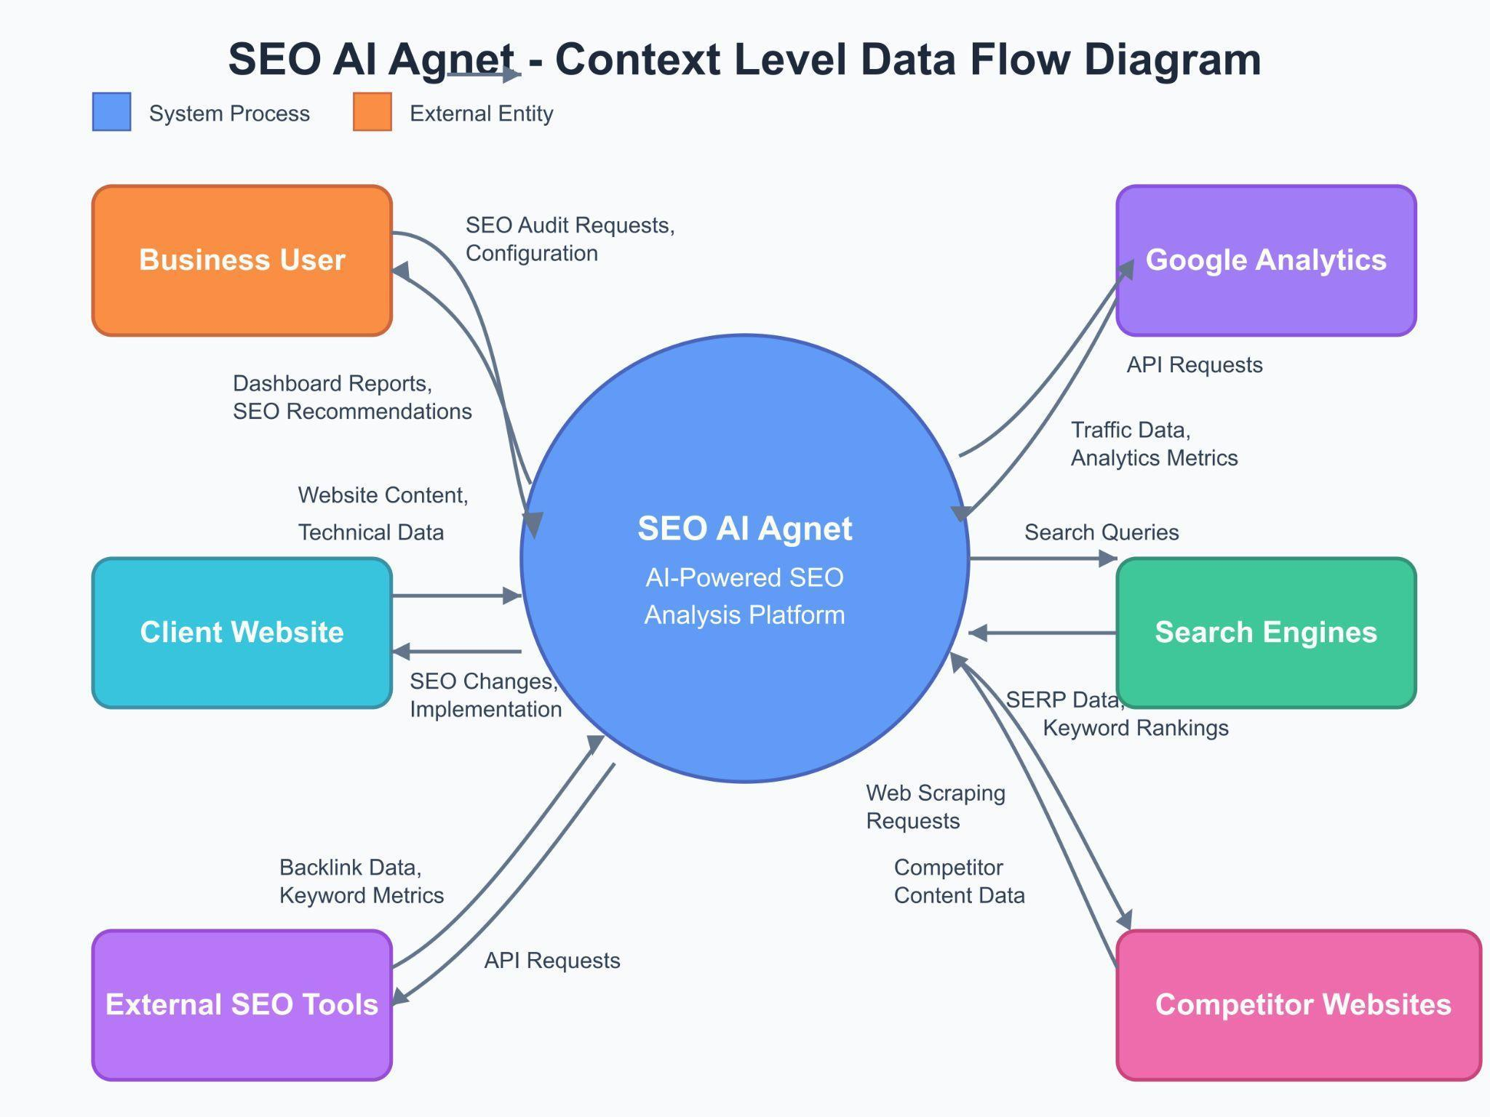

### **11.4 Capture "Shall" Statements**

The following "shall" statements define the system’s functional requirements in precise terms:

#### **11.4.1 SEO Audit Module**

* **The system shall perform technical audits** to assess website performance, mobile responsiveness, and crawlability.
* **The system shall execute on-page audits** that analyze meta tags, content quality, and keyword distribution.
* **The system shall conduct off-page audits** to evaluate backlink quality and online reputation.

#### **11.4.2 Data Integration Module**

* **The system shall integrate with external APIs** (e.g., Google Analytics) to retrieve real-time SEO metrics.
* **The system shall update data in real time,** ensuring that all analytical insights reflect current performance.

#### **11.4.3 AI Recommendation Module**

* **The system shall utilize AI algorithms** to process large datasets and provide personalized SEO recommendations.
* **The system shall deliver context-aware insights** based on user inputs and historical data trends.

#### **11.4.4 Dashboard & Reporting Module**

* **The system shall provide a customizable dashboard** that allows users to monitor key performance indicators (KPIs).
* **The system shall generate detailed reports** that can be exported in various formats.

#### **11.4.5 User Management & Security**

* **The system shall implement role-based access control** to ensure secure data access.
* **The system shall encrypt sensitive data** both in transit and at rest to comply with data protection standards.

### **11.5 Allocate Requirements**

Each functional requirement is mapped to specific system modules and use cases, ensuring complete coverage:

* **SEO Audit Module:** Allocated to the backend processing engine responsible for scheduling audits and generating reports.
* **Data Integration Module:** Allocated to the API management component, ensuring seamless data flow from external sources.
* **AI Recommendation Module:** Assigned to the AI engine, integrating LangChain and Ollama for advanced data analysis.
* **Dashboard & Reporting Module:** Mapped to the frontend UI/UX layer, ensuring data is presented in an intuitive and actionable format.
* **User Management & Security:** Distributed across both backend authentication services and frontend access controls.

### **11.6 Prioritize Requirements**

Requirements are prioritized to ensure that critical functionalities are developed first:

* **Highest Priority:**

1. Automated SEO Audits
2. Real-Time Data Integration
3. AI-Driven Recommendations
4. Role-Based User Management

* **Medium Priority:**

1. Customizable Dashboard
2. Detailed Reporting and Analytics
3. External API Integrations

* **Lowest Priority:**

1. Extended Customization Features
2. Advanced Data Export Options

### **11.7 High Level Use Case Diagram**

A high-level use case diagram illustrates the interactions between external actors and the SEO AI Agent system:

* **Business User Use Cases:**

1. **View SEO Dashboard:** Users interact with the dashboard to monitor key metrics.
2. **Generate Reports:** Users request detailed SEO performance reports.
3. **Receive AI Recommendations:** Users obtain personalized SEO suggestions based on data analytics.
4. **Manage Account Settings:** Users adjust profile settings and access controls.

* **System Administrator Use Cases:**

1. **Configure API Integrations:** Administrators manage connections to third-party data sources.
2. **Monitor System Health:** Administrators track system performance and apply updates or patches.
3. **User Management:** Administrators control access rights and enforce security protocols.

* **External API Use Cases:**

1. **Provide Real-Time Data:** External services (e.g., Google Analytics) supply necessary data for analysis.
2. **Support AI Processing:** AI service providers contribute to data analysis and recommendation generation.

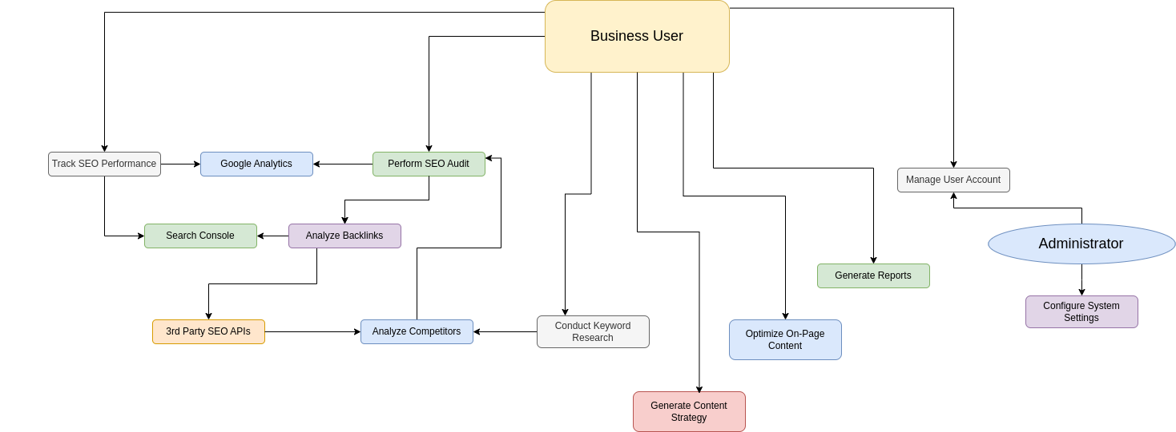

**12. Design Models**

**12.1 Architecture Design**

The diagram above illustrates the **SEO AI Agent** platform’s high-level architecture, showing how each component interacts to deliver a comprehensive, AI-powered SEO solution. Below is an in-depth explanation of the essential parts and their roles within the system:

### **1. Browser Client**

* **Role:** This is the end-user’s access point to the platform. Users open their web browser, navigate to the SEO AI Agent web interface, and interact with the system through an intuitive GUI.
* **Key Interactions:**

1. Submitting SEO audit requests
2. Viewing dashboards and reports
3. Managing account settings and user profiles

### **2. React/Next.js Frontend**

* **Role:** The frontend is built using React and Next.js to create a fast, responsive, and SEO-friendly user interface.
* **Key Advantages:**
* **Server-Side Rendering (SSR):** Improves page load speed and SEO performance.
* **Component-Based Structure:** Encourages code reusability and efficient maintenance.
* **Rich UI/UX:** Delivers a modern, interactive experience with real-time updates for SEO metrics.

### **3. Flask API Gateway**

* **Role:** Serves as the main entry point for all client requests, routing them to the appropriate microservices or modules.
* **Key Responsibilities:**

1. **Request Handling:** Validates incoming requests, applies authentication checks, and forwards them to the correct service.
2. **Response Aggregation:** Collects data or results from various services and packages them into a unified response for the frontend.
3. **Security & Rate Limiting:** Protects backend services from unauthorized access and excessive requests.

### **4. Authentication Service**

* **Role:** Manages user authentication and authorization, ensuring that only valid, authenticated users can access platform functionalities.
* **Key Features:**

1. **User Credential Storage:** Maintains a secure record of usernames, passwords, or tokens.
2. **Session Management:** Issues session tokens or JWTs (JSON Web Tokens) for validated users.
3. **Access Control:** Enforces role-based permissions for different user types (e.g., admin, SEO manager, business user).

### **5. AI Engine Module (LangChain & Ollama)**

* **Role:** Powers the advanced AI functionalities of the platform, particularly for tasks like Retrieval Augmented Generation (RAG) and context-aware SEO recommendations.
* **Core Functions:**

1. **Natural Language Processing (NLP):** Interprets user queries and content to provide relevant insights.
2. **Machine Learning Models:** Analyzes large datasets (e.g., site performance, competitor data) to generate predictive or prescriptive SEO recommendations.
3. **Dynamic Adaptation:** Continuously improves recommendation accuracy as it ingests new data over time.

### **6. Logging & Monitoring**

* **Role:** Tracks application performance, logs critical events, and monitors system health.
* **Why It’s Important:**

1. **Troubleshooting & Debugging:** Centralized logs help diagnose errors quickly.
2. **Performance Metrics:** Enables real-time visibility into response times, CPU usage, and other key metrics.
3. **Proactive Alerts:** Automated alerts inform the team of anomalies or performance bottlenecks before they impact end-users.

### **7. SEO Audit Service**

* **Role:** Automates comprehensive SEO audits, covering technical, on-page, and off-page factors.
* **Functions:**

1. **Technical Checks:** Examines site structure, page load speeds, mobile responsiveness, and crawlability.
2. **On-Page & Off-Page Analysis:** Evaluates meta tags, keyword usage, backlink quality, and more.
3. **Reporting:** Generates audit reports that can be viewed in the dashboard or exported as needed.

### **8. Keyword Research Service**

* **Role:** Identifies high-value keywords and search terms relevant to a user’s niche or business goals.
* **Core Features:**

1. **Volume & Competition Analysis:** Helps users discover keyword opportunities with high potential.
2. **Trend Monitoring:** Tracks changes in search volume over time, highlighting emerging keywords.
3. **Integration:** Works closely with the AI Engine to provide data for context-aware recommendations.

### **9. On-Page Optimization Service**

* **Role:** Focuses on improving on-page elements (e.g., titles, meta descriptions, content structure) to boost search visibility.
* **Key Activities:**

1. **Content Scoring:** Rates the SEO-friendliness of a webpage’s content.
2. **Optimization Tips:** Suggests improvements such as keyword placements, internal linking strategies, or media enhancements.

### **10. Content Strategy Service**

* **Role:** Provides strategic content planning to align with SEO goals and target audience needs.
* **Highlights:**

1. **Topic Generation:** Identifies trending topics and content gaps.
2. **Editorial Calendar Support:** Helps schedule and plan content releases for maximum impact.
3. **AI-Driven Insights:** Uses AI to recommend topics or formats that resonate with user intent.

### **11. Reporting & Analytics Service**

* **Role:** Aggregates data from audits, keyword research, and other services into meaningful reports and dashboards.
* **Features:**

1. **Custom Dashboards:** Lets users tailor analytics views (e.g., traffic, rankings, conversions).
2. **Historical Data Tracking:** Shows performance trends over time for informed decision-making.
3. **Export & Sharing:** Allows users to export reports in various formats (PDF, CSV) for offline analysis or presentations.

### **12. Link Building & Competitor Analysis Service**

* **Role:** Evaluates backlink profiles and competitor strategies to enhance domain authority and competitive edge.
* **Functions:**

1. **Backlink Audits:** Identifies high-quality vs. toxic links.
2. **Competitor Benchmarks:** Compares site performance, keyword overlap, and content strategies with key competitors.
3. **Strategy Recommendations:** Suggests link-building tactics, outreach opportunities, and content angles to outpace competition.

### **13. Vector Database**

* **Role:** Stores embeddings or vector representations for AI-based tasks (e.g., semantic search, RAG).
* **Why a Vector DB?:**

1. **High-Dimensional Data:** AI algorithms often produce vector embeddings that need specialized storage.
2. **Fast Similarity Search:** Enables quick retrieval of relevant documents or data points based on semantic similarity.
3. **Scalable:** Accommodates growing volumes of embedding data as the system processes more content.

### **14. PostgreSQL Database**

* **Role:** Acts as the main relational database for structured data, including user profiles, audit results, and system configurations.
* **Key Attributes:**

1. **ACID Compliance:** Ensures reliable transactions and data integrity.
2. **Scalability & Security:** Supports replication and partitioning for growing datasets, plus robust security features.
3. **Integration:** Communicates seamlessly with other services, providing a stable data backbone.

### **15. Third-Party Integrations (e.g., Google Analytics, Competitor Data)**

* **Role:** Supplies the system with external data, such as traffic statistics, competitor metrics, and additional SEO indicators.
* **Benefits:**

1. **Real-Time Insights:** Continuously updated metrics for accurate SEO analysis.
2. **Extended Feature Set:** Leverages external APIs to broaden the platform’s capabilities.
3. **Consolidated View:** Centralizes data from multiple sources into a single dashboard.

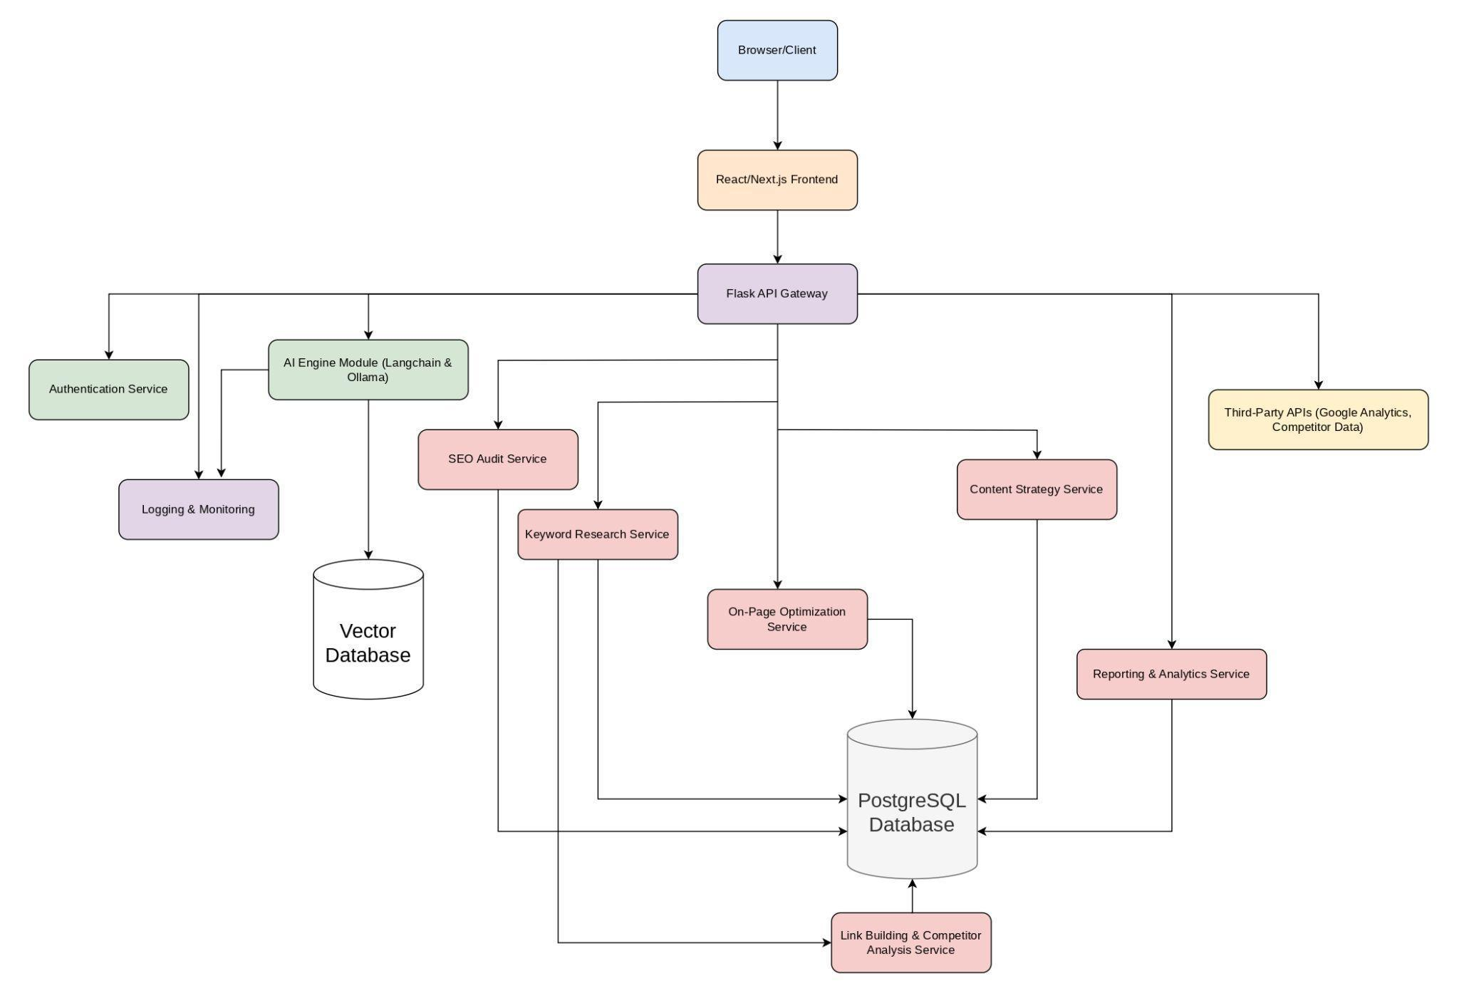

### **Data Flow Summary:**

1. **User Actions:** The Browser Client sends requests to the React/Next.js Frontend.
2. **API Routing:** The Flask API Gateway receives these requests and directs them to the relevant service (e.g., SEO Audit Service, Keyword Research Service).
3. **Processing & AI:** Certain requests may invoke the AI Engine Module for advanced analysis, leveraging the Vector Database and/or PostgreSQL Database for data retrieval and storage.
4. **Result Aggregation:** Services compile their findings, which are then sent back through the Flask API Gateway to the frontend.
5. **Visualization & Reports:** The user sees updated dashboards, analytics, or reports in real time, aided by the Reporting & Analytics Service.

**12.2 Class Diagram**

The class diagram provides a structural view of the SEO AI Agent system:

1. User Management: The User class represents system users who manage SEO projects.
2. Core Business Objects:
   * SEOProject: Central entity representing a website being analyzed
   * AuditResult: Stores results from technical, on-page, and off-page audits
   * KeywordAnalysis: Handles keyword research and tracking
   * ContentAnalyzer: Manages content optimization
3. System Components:
   * AIEngine: Powers all analytical features with methods for processing data and generating insights
   * ExternalAPIConnector: Facilitates data exchange with third-party services
   * Dashboard: Presents aggregated data and insights to users
4. Relationships: The diagram shows how these components relate to each other:
   * One-to-many relationship between Users and SEO Projects
   * One-to-many relationship between Projects and Audit Results
   * One-to-one relationships between Projects and analysis components
   * Support relationships showing how the AI Engine powers various features

Together, these diagrams provide complementary views of the SEO AI Agent system:

* The activity diagram shows the project timeline and workflow
* The sequence diagram illustrates runtime behavior and component interactions
* The class diagram defines the system's structure and relationships

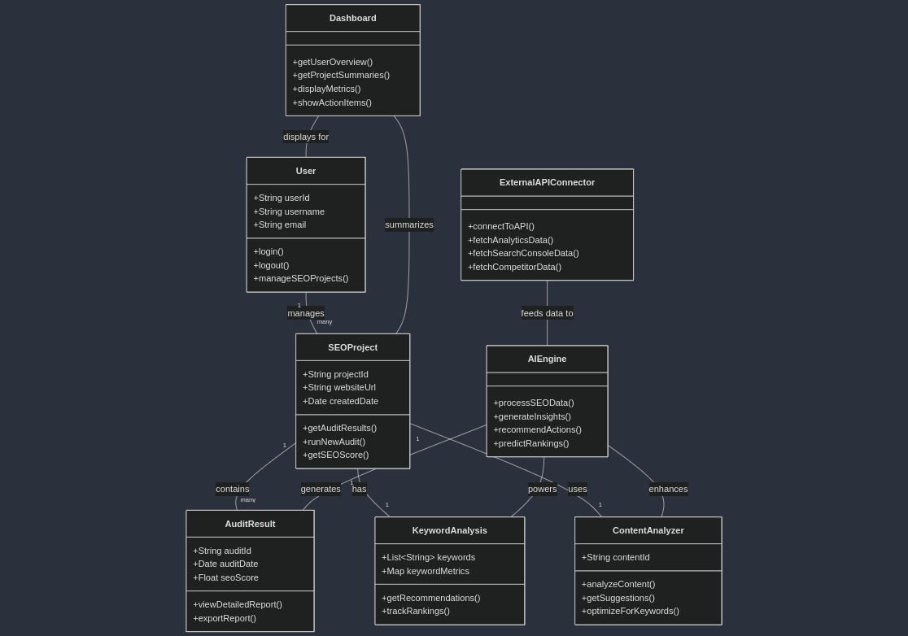

**12.3 Sequence Diagram**

The sequence diagram shows the interactions between different components of the SEO AI Agent system during typical user operations:

1. **Components**: The diagram includes six main actors/components:
   * User (the person using the system)
   * Frontend (Next.js UI)
   * Backend (Flask API)
   * AI Engine (LangChain/Ollama)
   * Database (PostgreSQL)
   * External APIs (Google Analytics, Search Console, etc.)
2. **Core Workflows**: The diagram uses an alternative fragment to show three primary workflows:
   * SEO Audit: Fetching website data from external sources, processing it through the AI engine
   * Keyword Research: Gathering keyword data and generating AI-powered recommendations
   * Content Optimization: Analyzing content directly through the AI component
3. **Common Pattern**: All workflows follow a similar pattern where data flows from the user through the system components and back, with the AI engine providing the analytical intelligence and the database storing results.

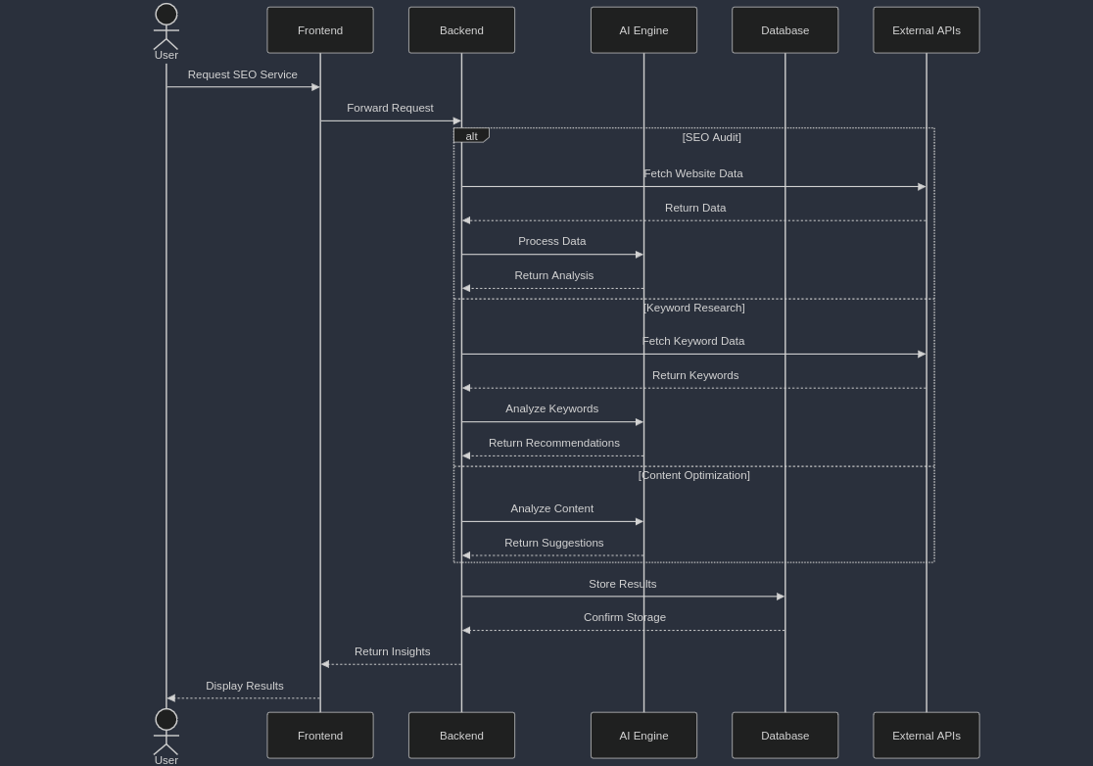

**12.4 Activity Diagram**

The activity diagram illustrates the high-level workflow of the SEO AI Agent project from start to finish. It shows a linear progression through the main project phases:

1. **Planning Phase**: Consolidates requirements gathering, literature review, and design activities into a single starting block.
2. **Development Phase**: Shows three parallel development tracks that happen simultaneously:
   * Frontend development using Next.js/React
   * Backend development using Flask API
   * AI module implementation using LangChain/Ollama
3. **Integration Phase**: Represents the point where the separately developed components come together into a unified system.
4. **Testing Phase**: Encompasses all testing activities, including system testing and user acceptance testing.
5. **Deployment Phase**: The final stage showing deployment and documentation activities.

The diagram uses a simple top-down flow to clearly communicate the project progression while highlighting the parallel nature of the development work.

